**Question 1**

Suppose that there are three consumers, David, Stephen, and Sylvia, who enjoy drinking lemonade. Their demand curves for glasses of lemonade are given by

David: P = 8 – 2Q

Stephen: P = 8 – Q

Sylvia: P = 8 – 4Q

Solve for the equation for the market demand curve and illustrate it on a graph.

**Answer:**

First, we need to graph the demand curves for each consumer.

[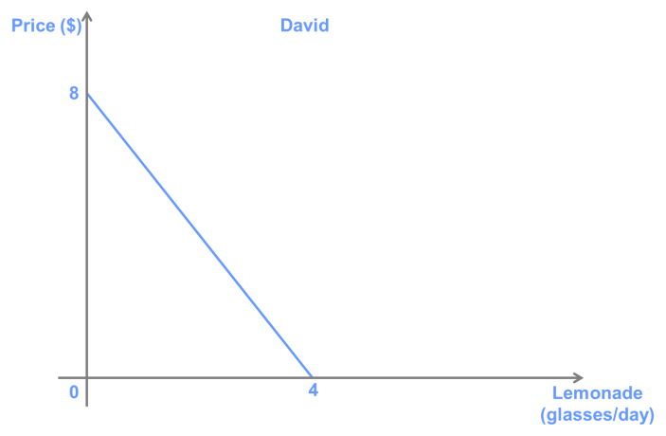](http://lionsheartstudios-publishing.com/unsw/wp-content/uploads/sites/17/2016/03/Ch4_Q1_Ans_2.png)

[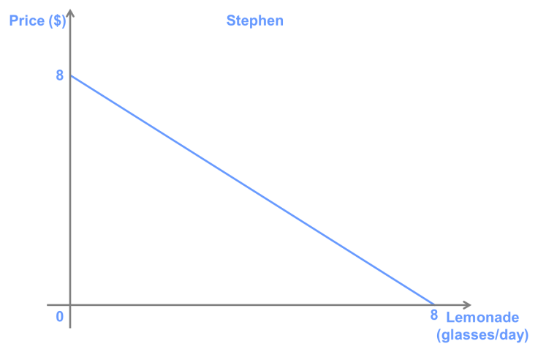](http://lionsheartstudios-publishing.com/unsw/wp-content/uploads/sites/17/2016/03/Ch4_Q1_Ans_2.png)

[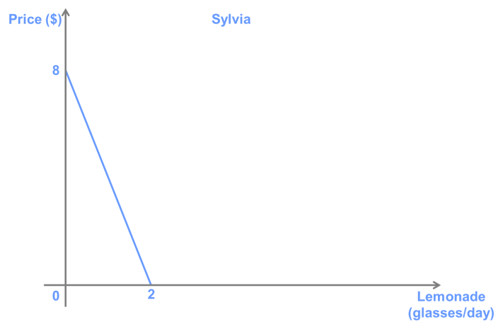](http://lionsheartstudios-publishing.com/unsw/wp-content/uploads/sites/17/2016/03/Ch4_Q1_Ans_3.png)

To find the market demand curve, we need to sum these three demand curve *horizontally*. To do this, for each price, we sum the quantity demanded by all the consumers. In this case, because each consumer has a linear demand curve with the same vertical intercept, we only need to calculate one other point to draw the market demand curve. For example, the horizontal intercept (when *P* = 0), is equal to 14 (4 + 8 + 2), so the graph looks like the following:

[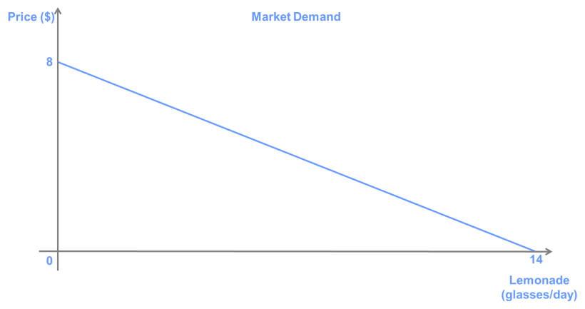](http://lionsheartstudios-publishing.com/unsw/wp-content/uploads/sites/17/2016/03/Ch4_Q1_Ans_T1.png)

We can use the point-slope formula (*y*=*mx*+*b*) to find that the equation for market demand is *P* = 8 – (4/7)x*Q*.

(Alternatively, we could have rearranged each equation to isolate Q as a function of P (i.e., *Q* = 4 – *P*/2 in the case of David) and added all terms on the right-hand side of the equation. You can check that this give the same answer. This is because this implicitly sums the quantity that each person consumes at a given price.)

**Question 2**

Suppose that the price in a perfectly competitive market is above the equilibrium price. Explain how market forces will influence the price in the market.

**Answer:**

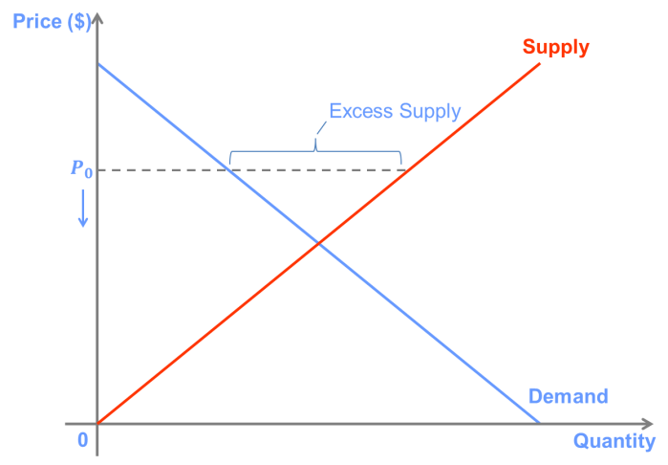

If the price in a market is above the market equilibrium price (the price at which quantity supplied is equal to quantity demanded), then there will be an excess supply in the market. As a result, sellers that are unable to attract a customer will have an incentive[刺激] to lower their prices in order to attract buyers. Thus, the price will tend to fall until it reaches the market equilibrium price.

**Question 3**

Suppose that the demand and supply curves for a market can be represented by the following equations:

Demand: Q = 60 – 4P

Supply: Q = 2P

A. Draw the supply and demand curves on a graph.

B. What is the equilibrium price and quantity in this market?

C. Show on your graph and calculate the consumer surplus, producer surplus, and total surplus at the equilibrium price and quantity.

**Answer:**

A.

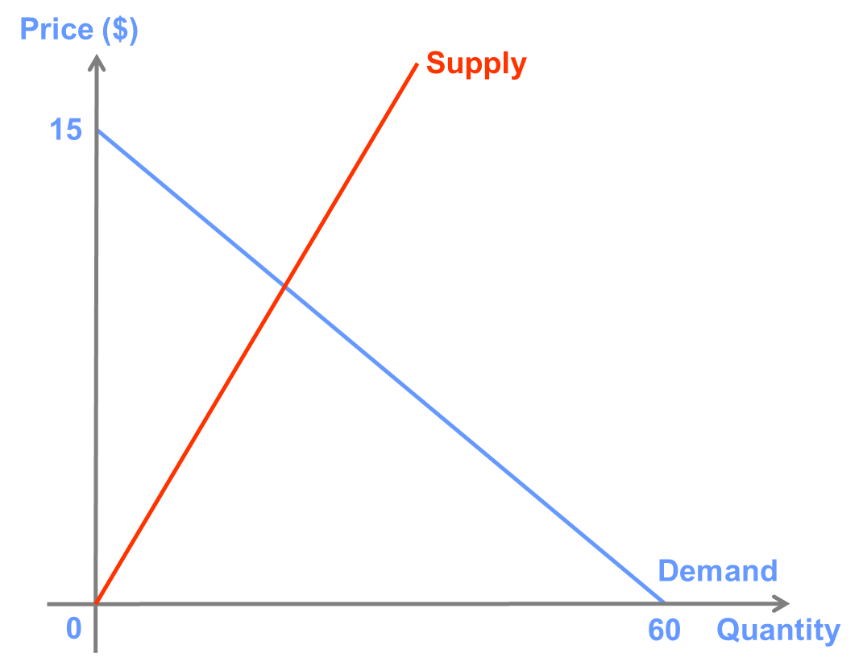

B.60-4P=2P P=10,Q=20

C. consumer surplus=5*20/2=50

Producer surplus=10*20/2=100

Total surplus=50+100=150

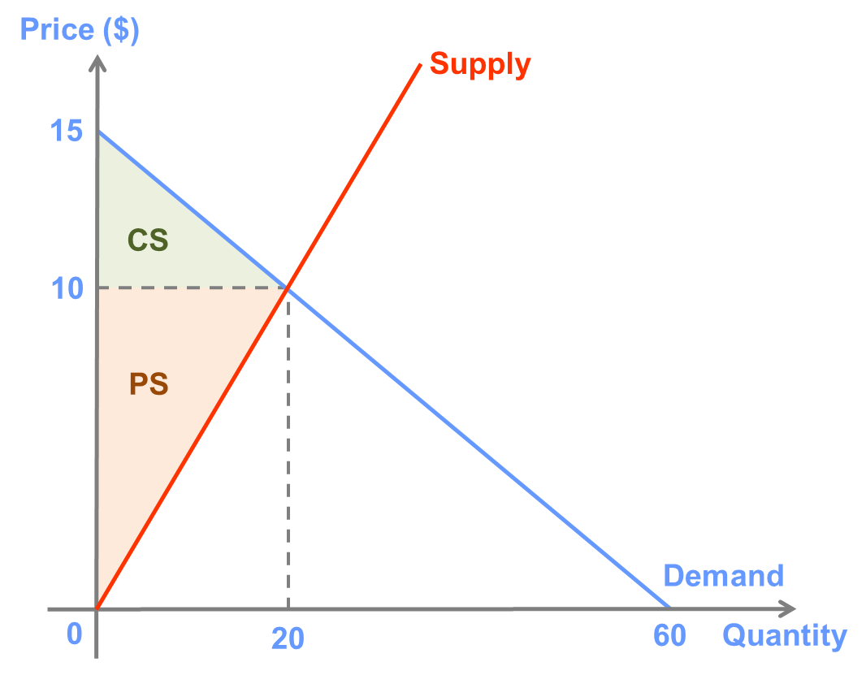

**Question 4**

Suppose that the demand curve for a product is given by the equation

Q = 25 – 4P,

and supply is given by

Q = P.

A. What is the competitive market equilibrium price and quantity?

B. Calculate the producer surplus and consumer surplus generated by the market in equilibrium.

C. Calculate producer and consumer surplus if the price were equal to $6.

D. Explain why the total surplus is greater or less than that when the market is in equilibrium.

**Answer:**

A.25-P=P P=5,Q=5

B. consumer surplus=3.125

Producer surplus=12.5

C. consumer surplus=0.125

Producer surplus=5.5

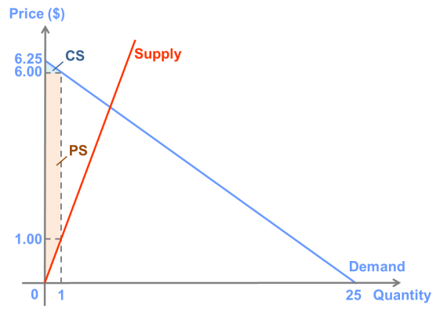

At $6, the quantity demanded is equal to 1 (there is an excess supply that will not be purchased). Thus,

CS = (6.25 – 6)x1/2 = $0.125

PS = (6 – 1)x1 + (1 – 0)x1/2 = $5.50

To see how these were calculated, it is helpful to draw the graph. Here, producer’s surplus was calculated as the area of the shaded rectangle between $1 and $6, plus the area of the shaded triangle between $0 and $1.

D. When the price is above the market equilibrium price, the reservation price of the marginal buyer is greater than the reservation price of the marginal seller. This means that it is possible to increase total surplus if the seller sells one more unit of the good to the buyer at any price below the current (too high) market price. This is true for every price other than the equilibrium price, which is the price for which the reservation price of the marginal seller is equal to the reservation price of the marginal buyer. This is why the equilibrium price is the price for which total surplus is maximised, and thus total surplus will be smaller at any other price.

**Question 5**

Suppose that the demand curve for a product is given by the equation

Q = 40 – 3P,

and supply is given by

Q = –10 + 2P.

A. What is the value of the price elasticity of demand and the price elasticity of supply at the market equilibrium price and quantity?

B. Calculate the producer surplus, consumer surplus, and total surplus at the market equilibrium price and quantity.

C. Suppose that the entry of new firms causes the supply curve to become Q = 2P. Calculate the price elasticities of supply and demand and the new value of consumer, producer, and total surplus at the new market equilibrium price and quantity.

**Answer:**

A.40-3P=-10+2P P=10,Q=10

E(demand)=1/(-1/3)*(10/10)=-3

E(supply)=1/(1/2)*(10/10)=2

B.producer surplus=1/2*5*10=25

Consumer surplus=1/2*10*10/3=50/3=16.67

Total surplus=125/3=41.67

C.40-3P=2P P=8,Q=16

E(demand)=1/(-1/3)*(8/16)=-1.5

E(supply)=1/(1/2)*(8/16)=1

Producer surplus=1/2*8*16=64

Consumer surplus=1/2*(16/3)*16=128/3=42.67

Total surplus=320/3=106.67

**Question 6**

Show on a graph and explain how each of the following would affect the equilibrium price and quantity in a perfectly competitive market.

A. The effect of a decrease in the price of iron ore on the market for automobiles.

B. The effect of a study showing negative effects of red meat consumption on health on the market for hamburgers.

C. The effect of a cyclone that destroys a large share of Australian banana trees and a simultaneous decrease in income on the market for bananas. (Assume bananas are an inferior good.)

D. The effect of a new, more efficient technique for making bread on the market for pasta. (Make your own assumptions about the relationships between bread and pasta.)

**Answer:**

****A.****

Iron ore is an input into the production of automobiles, so a decrease in the price will cause the supply curve to shift to the right. This results in a decrease in the equilibrium price, and an increase the equilibrium quantity.

[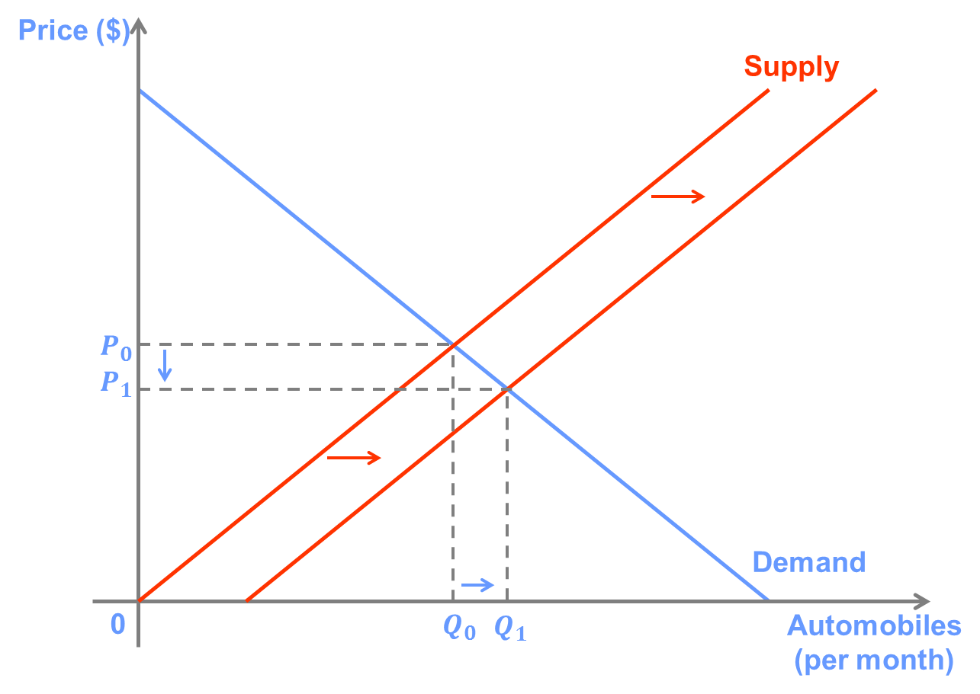](http://lionsheartstudios-publishing.com/unsw/wp-content/uploads/sites/17/2016/03/Ch4_Q6_Ans_A.png)

****B.****

The new information will most likely reduce the quantity demanded of red meat for any price, so it will cause the demand curve to shift to the left. This results in a decrease in the equilibrium price, and a decrease the equilibrium quantity.

[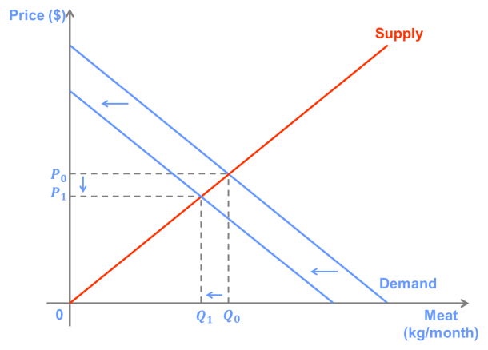](http://lionsheartstudios-publishing.com/unsw/wp-content/uploads/sites/17/2016/03/Ch4_Q6_Ans_B.png)

****C.****

The destruction of banana trees will cause the supply curve to shift to the left, while the decrease in income will cause the demand curve to shift to the right (because bananas are an inferior good). This results in a large increase in the equilibrium price but an ambiguous effect on the equilibrium quantity. In the figure drawn, the effect of the change in supply dominates, so *Q* decreases slightly.

[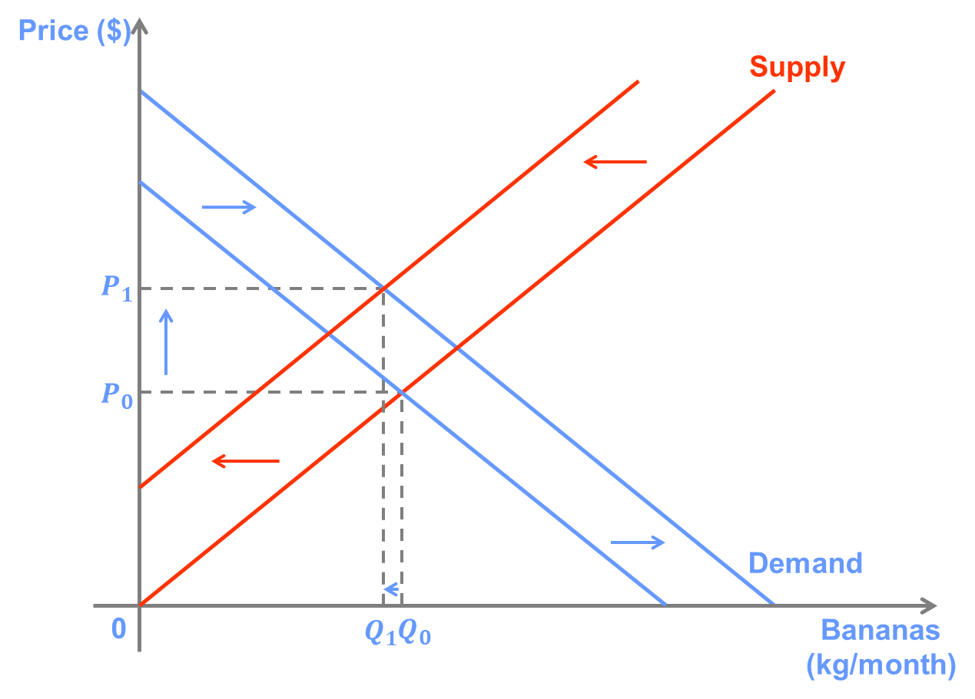](http://lionsheartstudios-publishing.com/unsw/wp-content/uploads/sites/17/2016/03/Ch4_Q6_Ans_C.png)

****D.****

Bread and pasta are likely substitutes in consumption. The new technology should lower the market price for bread, which will cause a decrease in demand for pasta (a leftward shift of the demand curve). This results in a decrease in the equilibrium price, and a decrease the equilibrium quantity.

[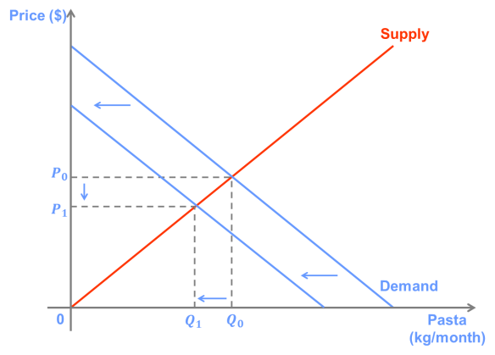](http://lionsheartstudios-publishing.com/unsw/wp-content/uploads/sites/17/2016/03/Ch4_Q6_Ans_D1.png)

**Question 7**

Suppose that the market for kebabs in Sydney is in a long-run competitive equilibrium with 1,000 shops each selling 100 kebabs per day at a price of $8 each.

A. Illustrate the market equilibrium using a graph for the entire market and one for a typical shop in the market.

B. Suppose that there is a large increase in the number of burrito shops in Sydney. Use your graphs to illustrate the short-run effect of this change on the equilibrium price and quantity of kebabs sold in Sydney as well as on the profit of a typical kebab shop.

C. Next, use the graphs to show how each of these variables will be affected in the long run.

**Answer:**

****A.****

[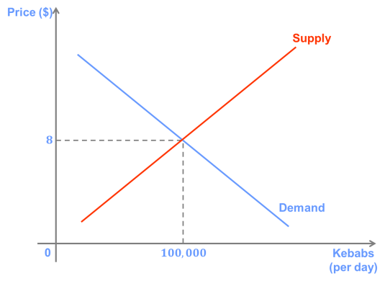](http://lionsheartstudios-publishing.com/unsw/wp-content/uploads/sites/17/2016/03/Ch4_Q7_Ans_A1.png)  [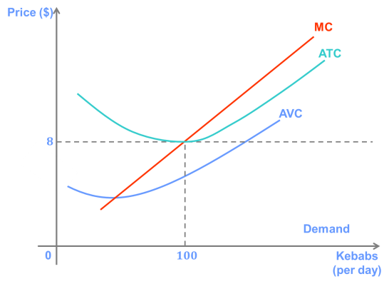](http://lionsheartstudios-publishing.com/unsw/wp-content/uploads/sites/17/2016/03/Ch4_Q7_Ans_A2.png)

Note that in a long-run equilibrium, a typical firm will earn zero profit. This happens when the price is equal to the firm’s minimum average total cost.

****B.****

Assuming that burritos and kebabs are substitutes, this implies that demand for kebabs will decrease, lowering the equilibrium price, and causing the kebab shops to make a loss.

[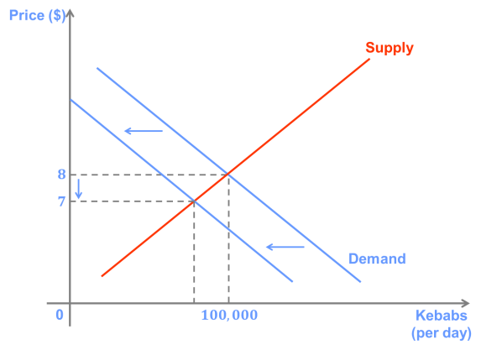](http://lionsheartstudios-publishing.com/unsw/wp-content/uploads/sites/17/2016/03/Ch4_Q7_Ans_B1.png)   [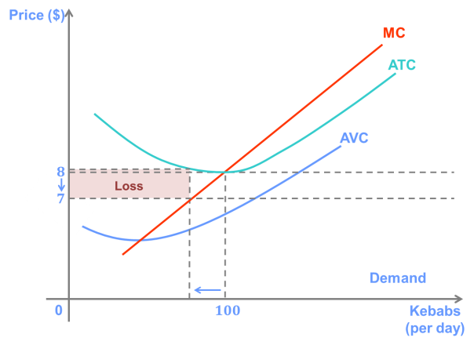](http://lionsheartstudios-publishing.com/unsw/wp-content/uploads/sites/17/2016/03/Ch4_Q7_Ans_B2.png)

****C.****

In the long run, kebab shops that are making a loss will exit the market, shifting the short-run supply curve to the left, causing the price to increase until the remaining kebab shops are again just breaking even.

[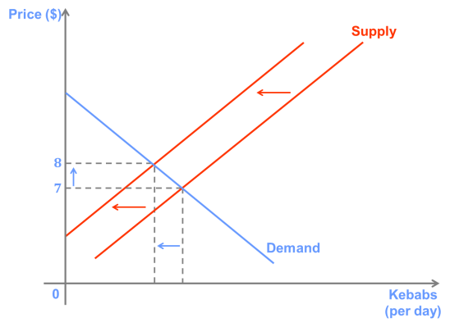](http://lionsheartstudios-publishing.com/unsw/wp-content/uploads/sites/17/2016/03/Ch4_Q7_Ans_C11.png)  [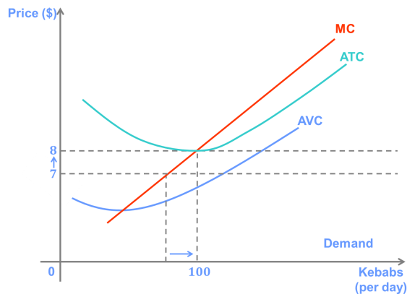](http://lionsheartstudios-publishing.com/unsw/wp-content/uploads/sites/17/2016/03/Ch4_Q7_Ans_C21.png)